1.Scenario: A college wants to register a student with default information when no details are provided.
Requirements:
1. Create a class Student with variables studentId, studentName, and course. 2. Create a class with no explicitly declared constructor and observe the default values assigned to its instance variables. 3. Create a method displayDetails() to display the student information. 4. Create an object and call the display method.
Task: What values will be displayed if the variables are not initialized?
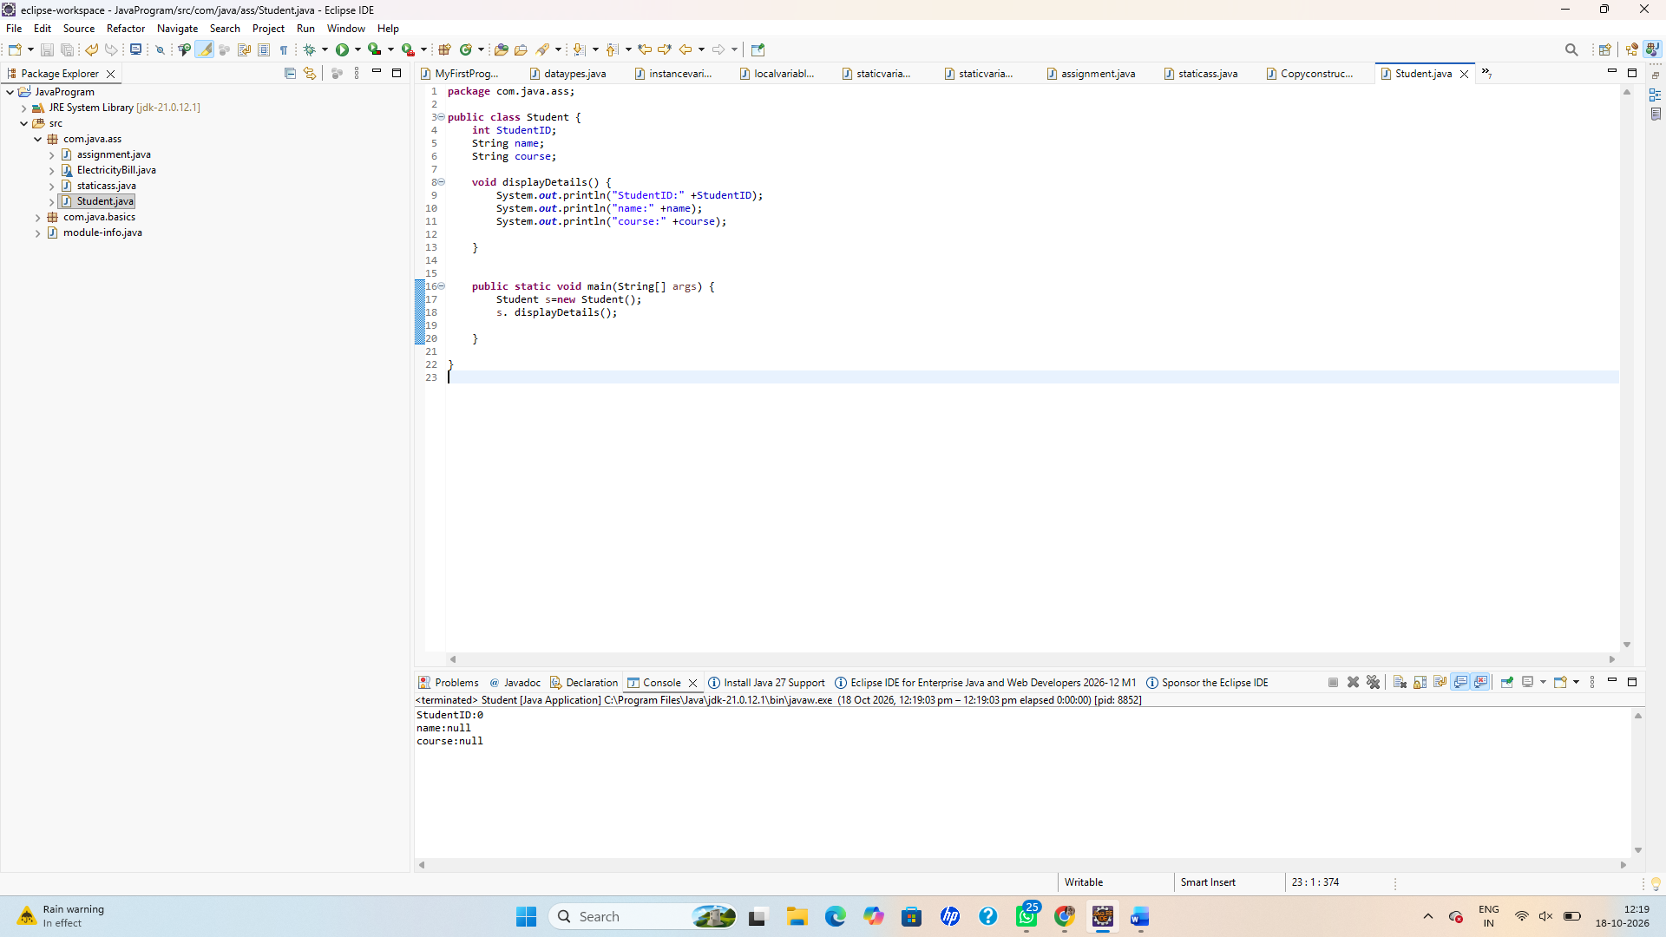
2.Scenario:
A bank automatically creates a savings account with predefined initial details.
Requirements: 1. Create a class BankAccount with accountNumber, holderName, and balance. 2. Create a no-argument constructor that initializes them to 1001, "Priya", and 5000.0. 3. Create a method displayAccount() to display the details. 4. Create two objects and display their details.
Task: Explain how the no-argument constructor initializes each object.
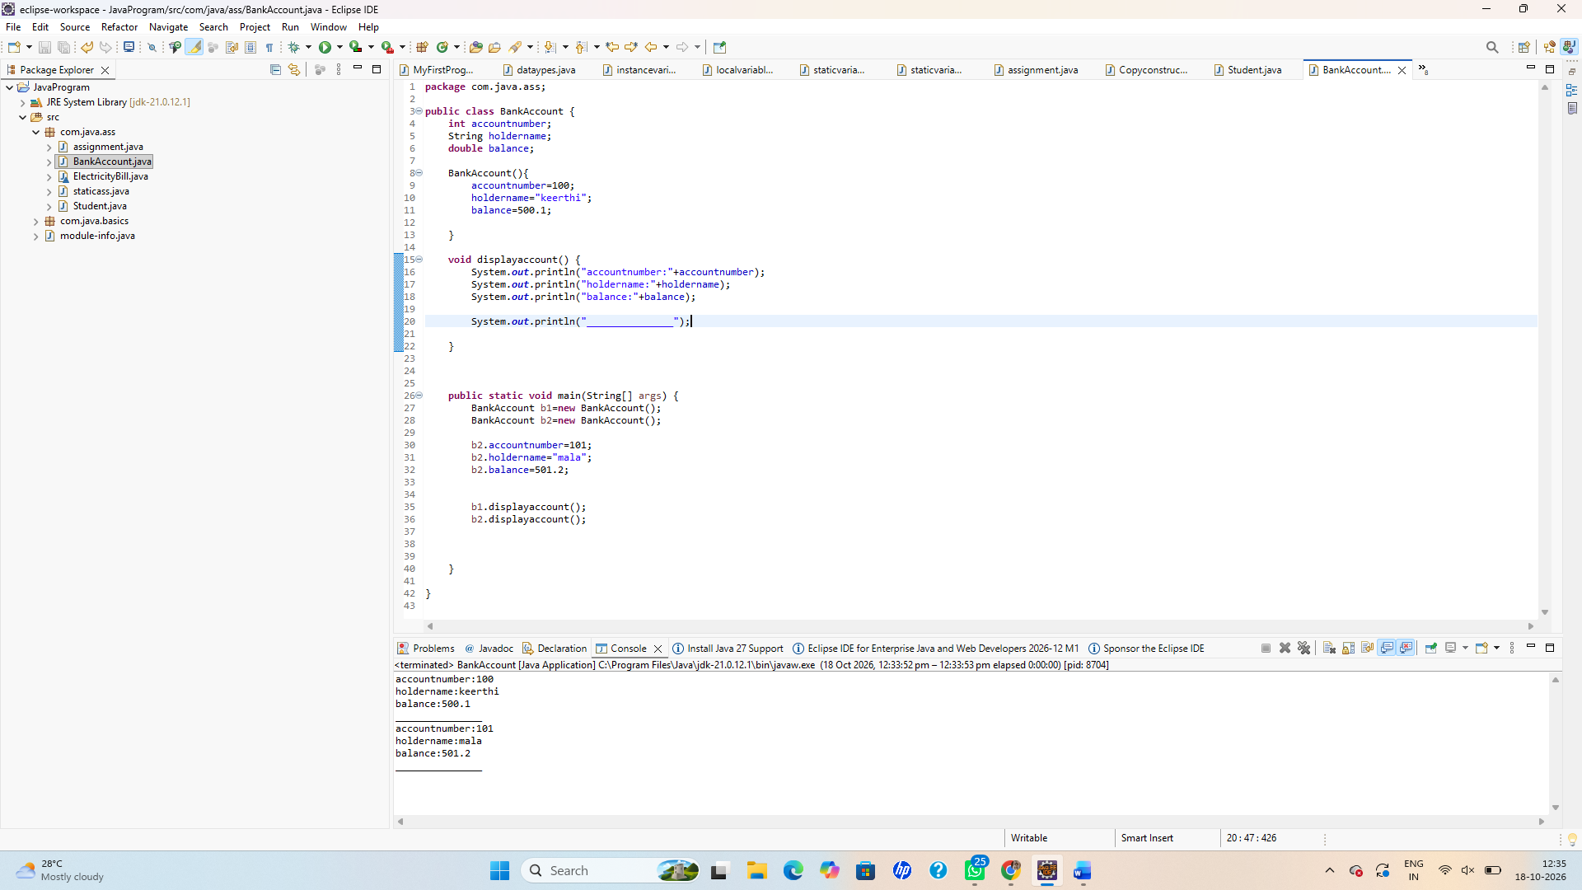
3.Scenario:
A company needs to store different employee details when each employee joins.
Requirements: 1. Create a class Employee with employeeId, employeeName, and salary. 2. Create a parameterized constructor that accepts all three values. 3. Create a method calculateAnnualSalary() that calculates annual salary. 4. Create three employee objects with different details and display their annual salaries.
Sample input: ● Employee 1: 101, "Arun", 25000 ● Employee 2: 102, "Divya", 35000 ● Employee 3: 103, "Kumar", 40000
Task: Calculate and display the annual salary for each employee.
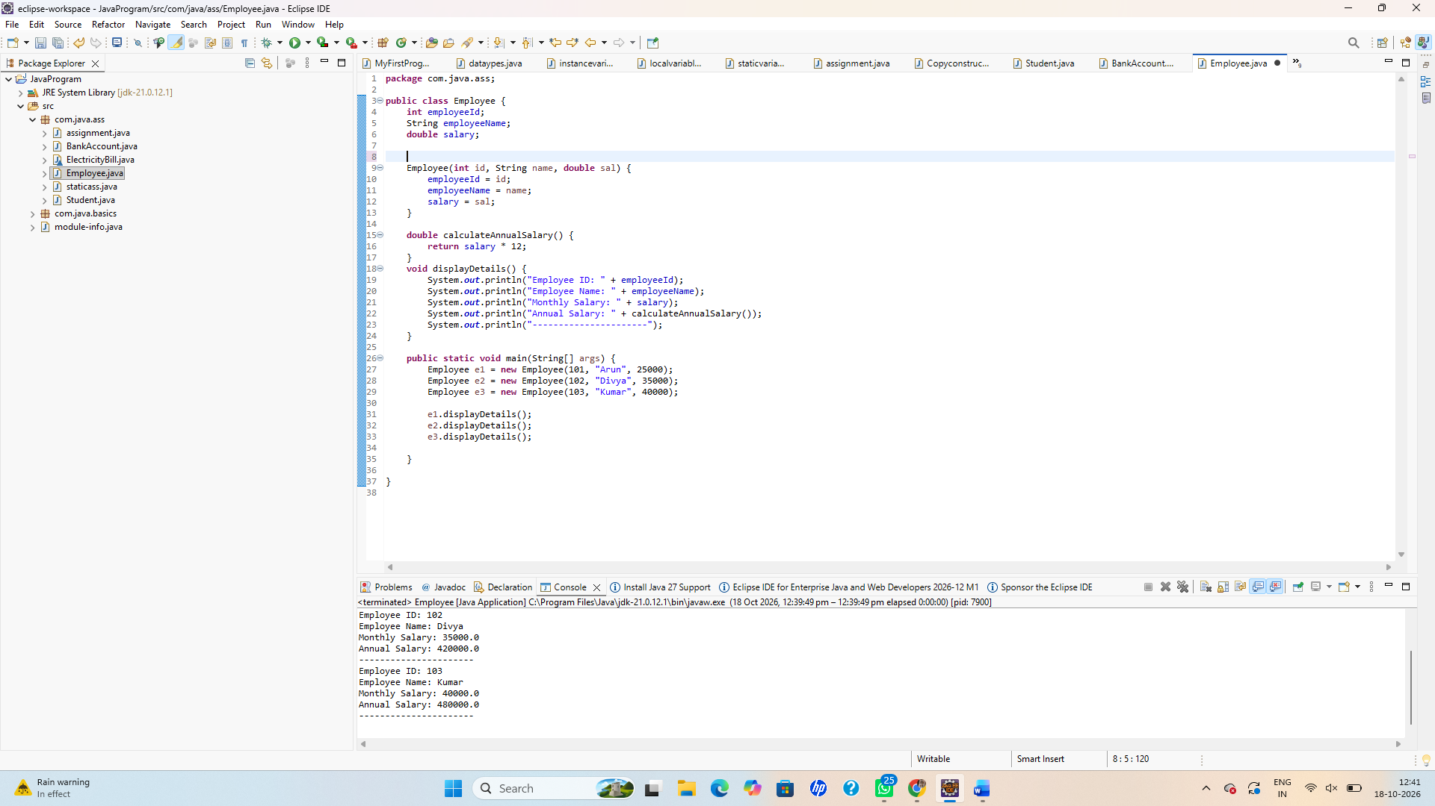
4.Scenario: An online shopping application allows products to be created with different levels of information.
Requirements: 1. Create a class Product with productId, productName, and price. 2. Create three constructors: ○ A no-argument constructor. ○ A constructor accepting productId and productName. ○ A constructor accepting productId, productName, and price. 3. Initialize appropriate values in each constructor. 4. Create three objects, each using a different constructor. 5. Display all product details.
Task: Demonstrate how Java selects the correct constructor based on the arguments supplied.
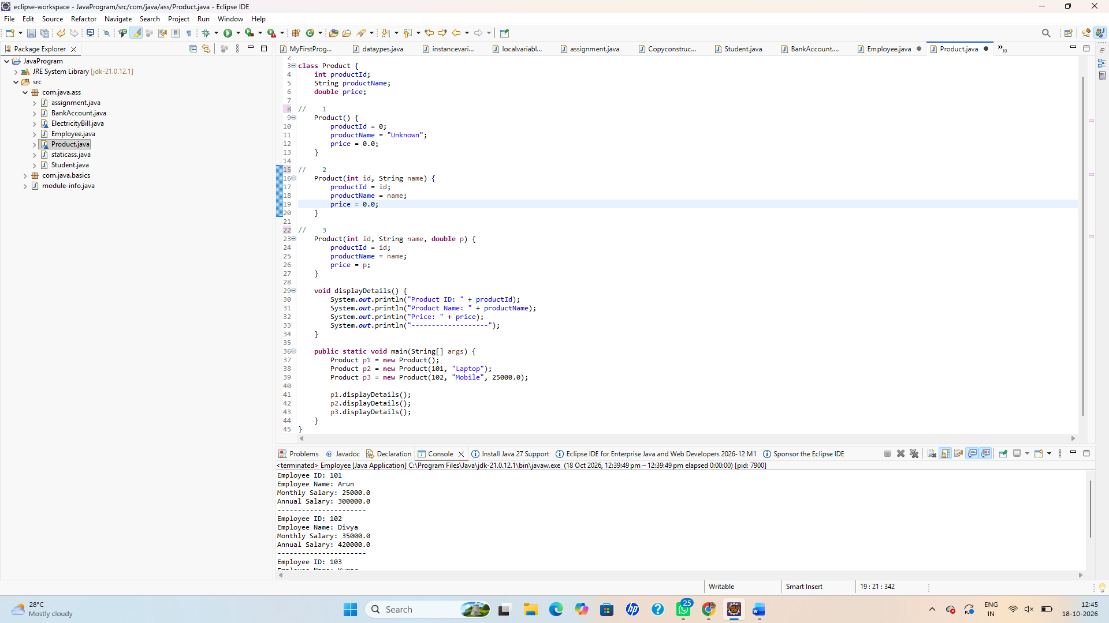
5.Scenario: A school needs to create a new student record by copying the details of an existing student.
Requirements: 1. Create a class StudentRecord with rollNumber, studentName, and marks. 2. Create a parameterized constructor to initialize the original student's details. 3. Create a copy constructor that accepts another StudentRecord object and copies its values. 4. Create an original student object and a copied student object. 5. Change the copied student's marks and display both records.
Task: Verify that changing the copied object's marks does not change the original object's marks.
